In Class Assignment 6

Dimantha Goonewardena (500237785)

Sujan Thapa (500236989)

Paramjit Singh (500229051)

Jaspal Singh (

Divyanshu (500235681)

**Folder Structure**

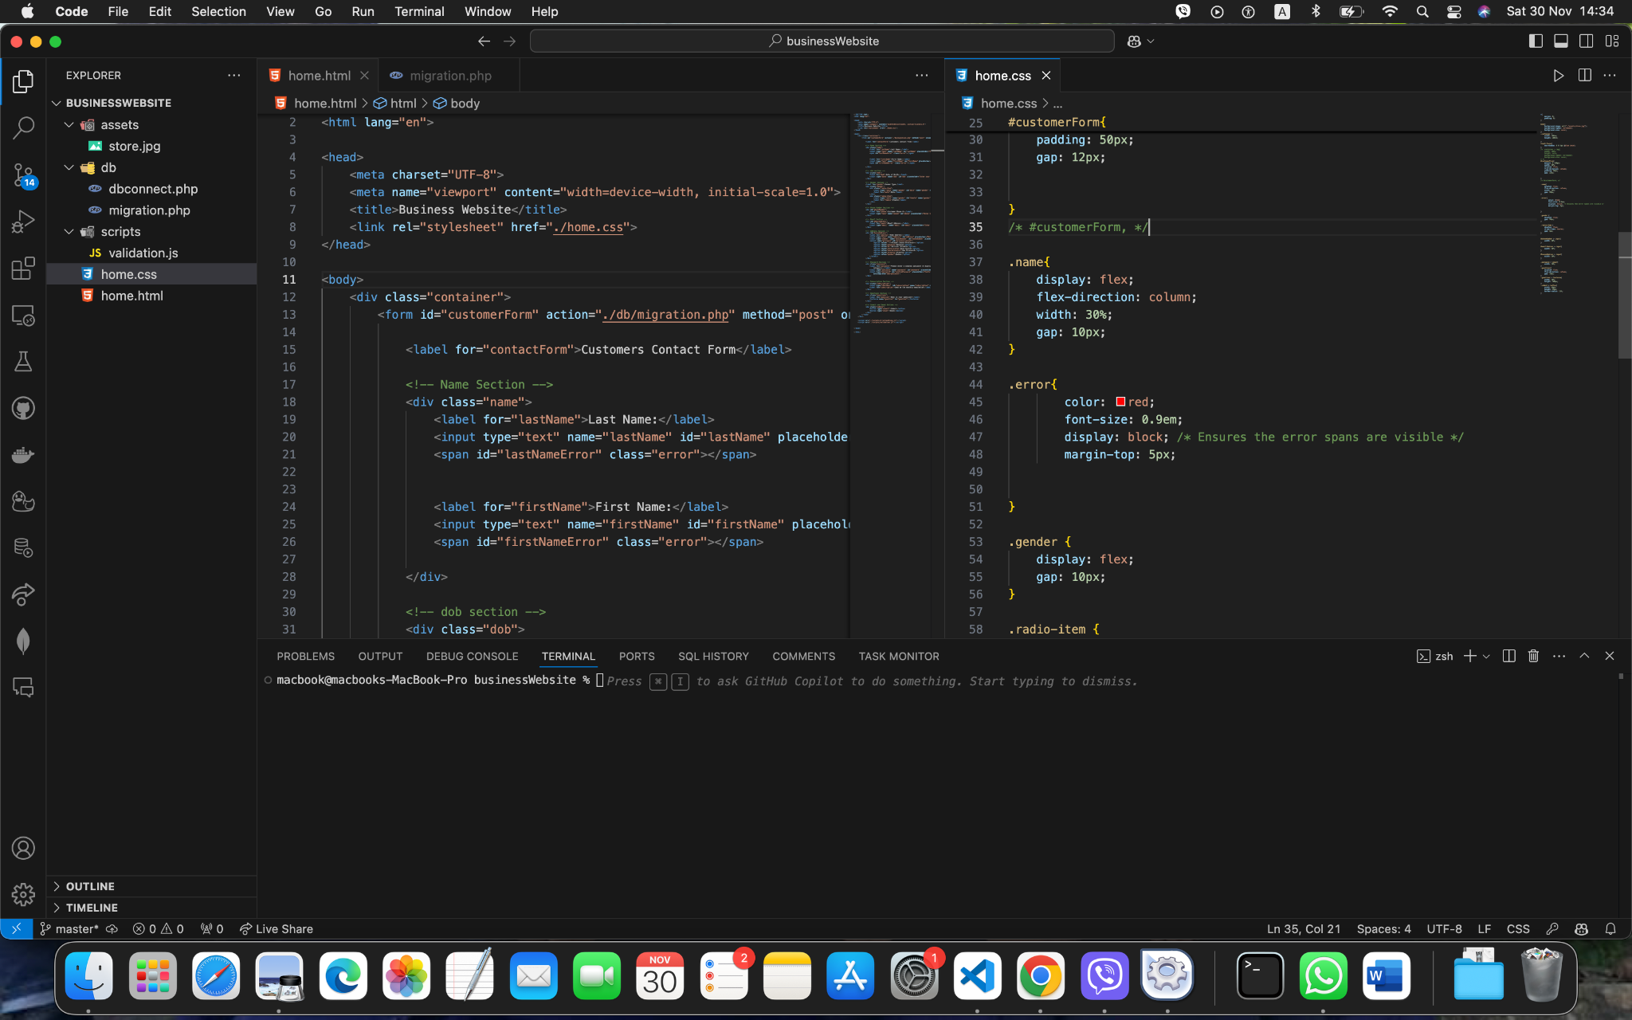

Figure 1: Folder structure for the business website

Database Structure

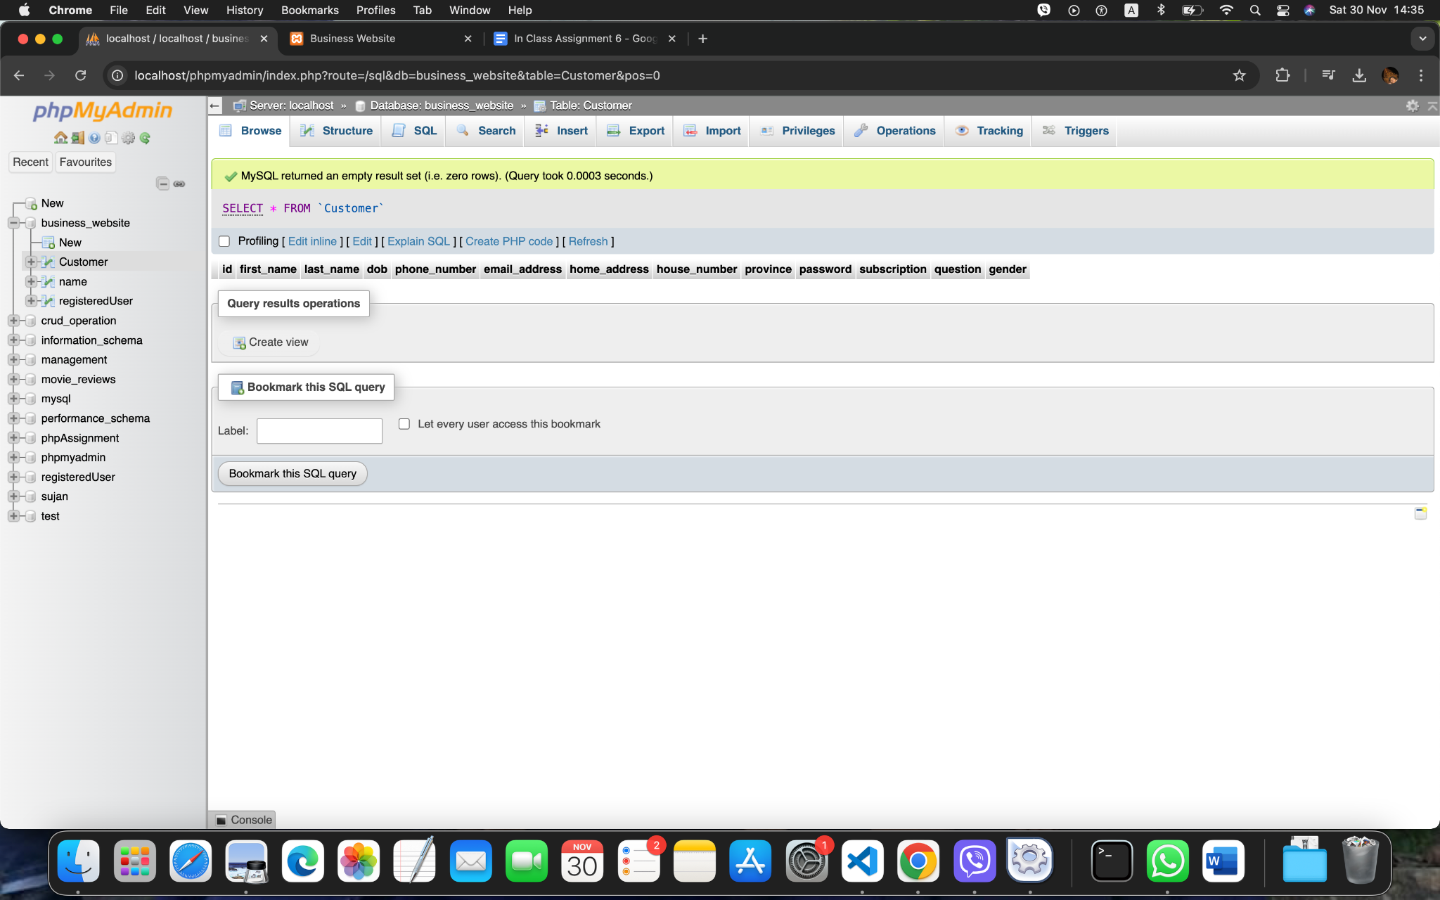

Figure 2: Database Structure for the system.

Layout

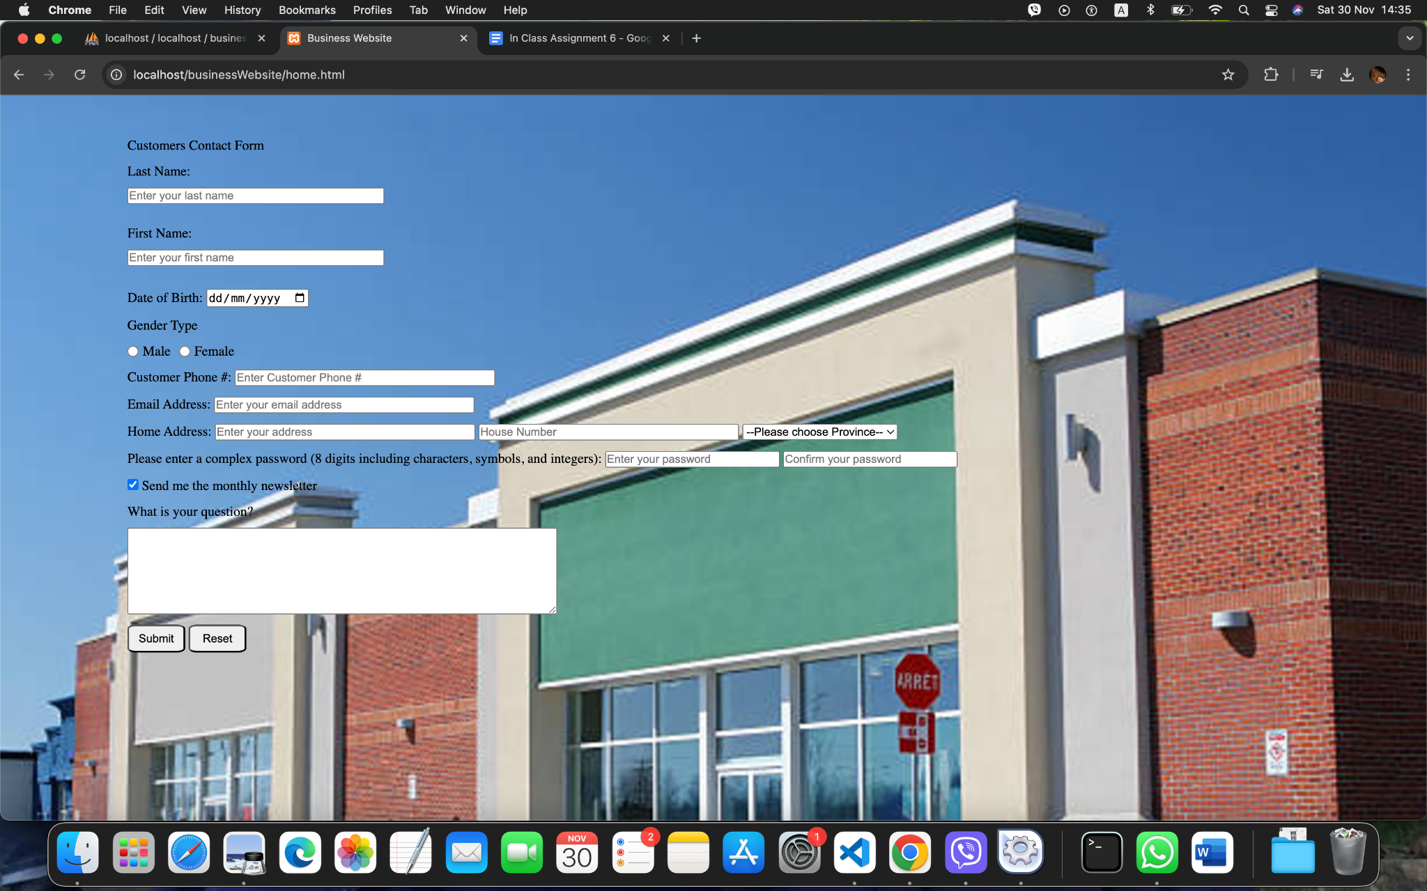

Figure 3: Layout of the system.

**Customer First Name and Last Name**

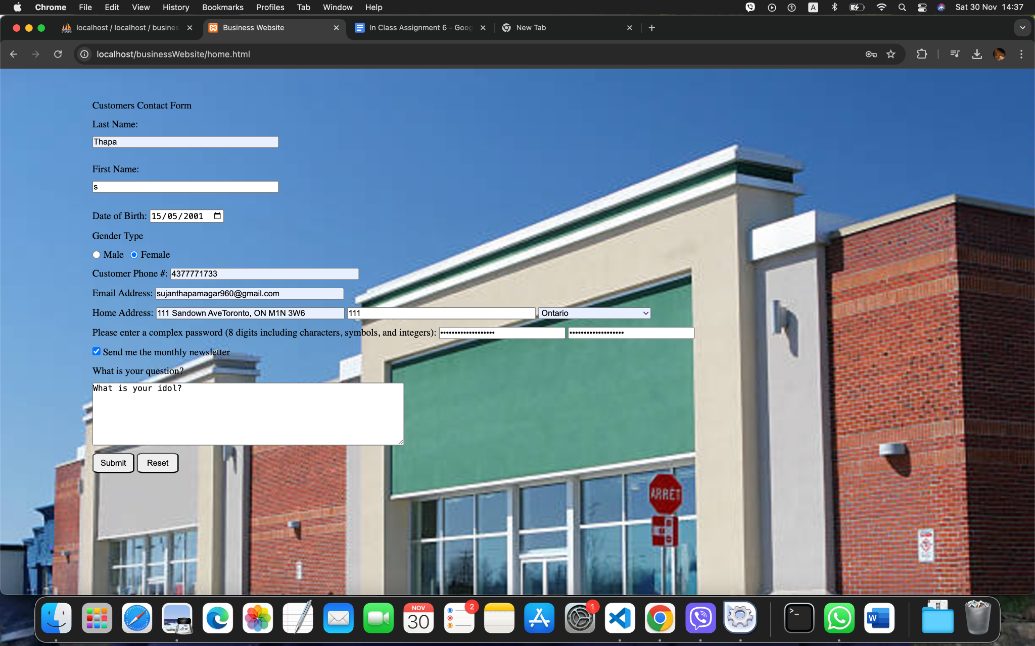

Figure 4: Passing First Name below two characters.

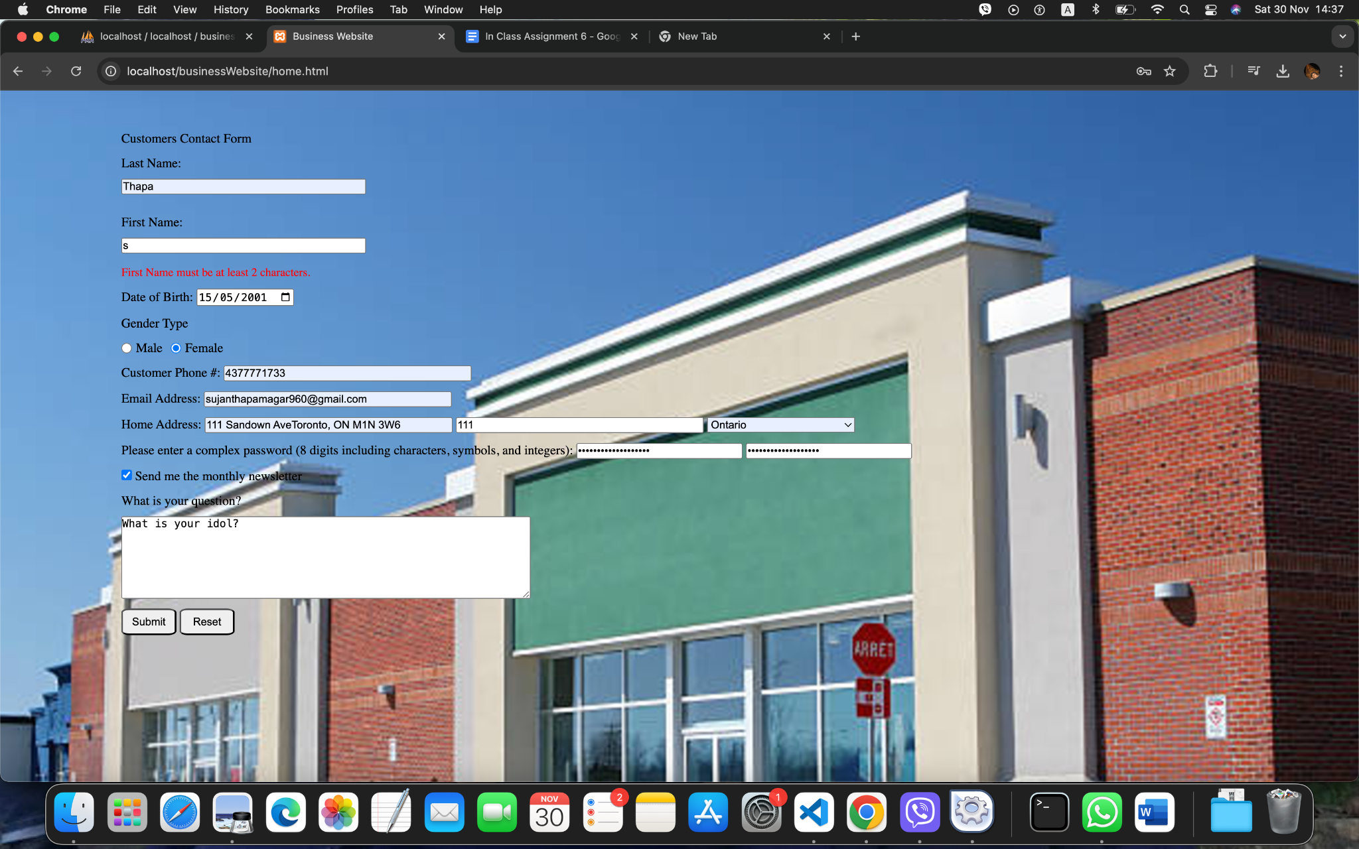

Figure 5: Showing error.

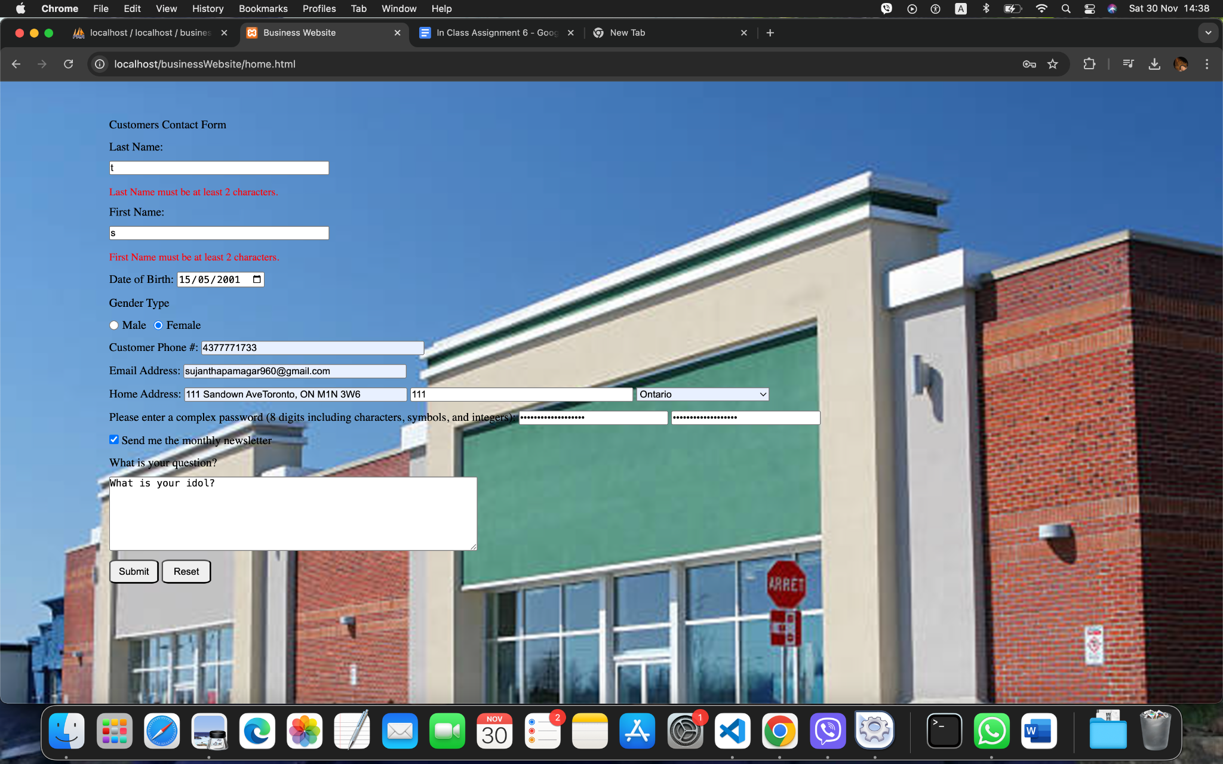

Figure 6: Testing the first name and last name validation.

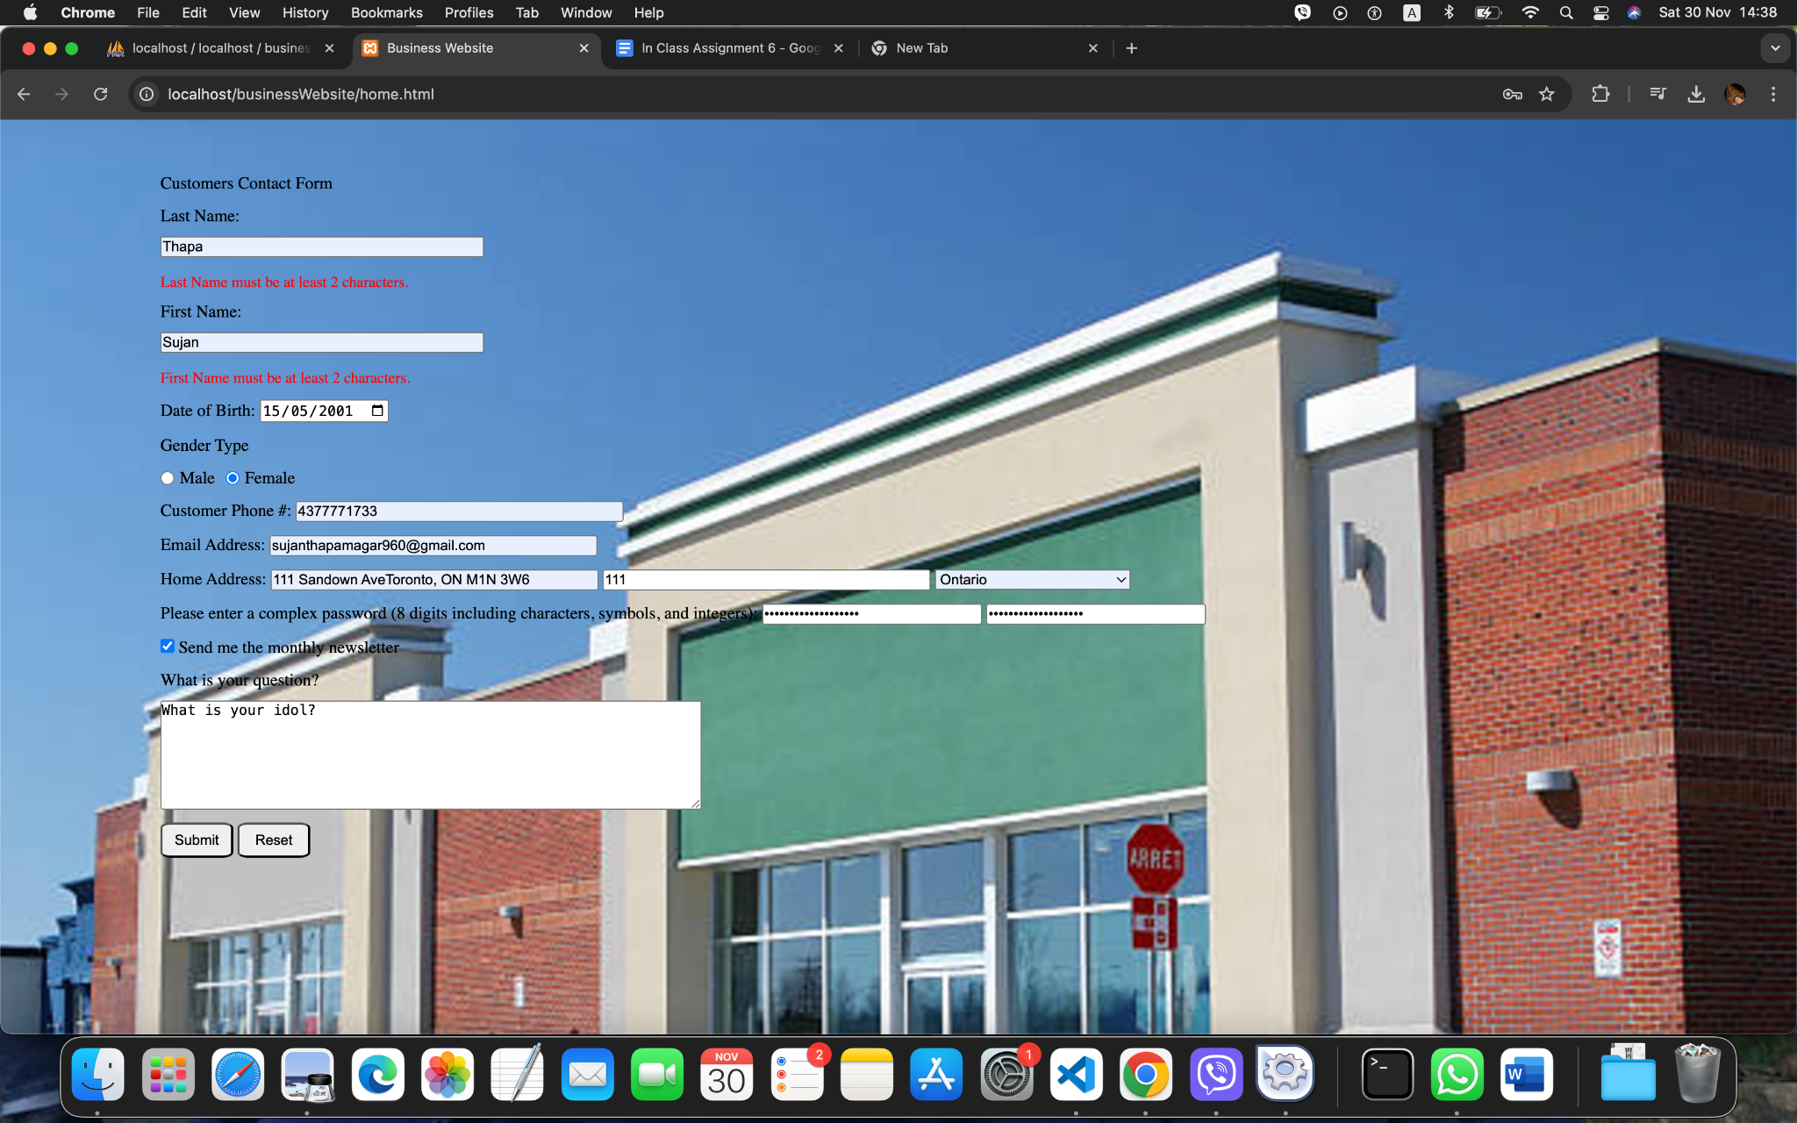

Figure 7: Passing the valid information.

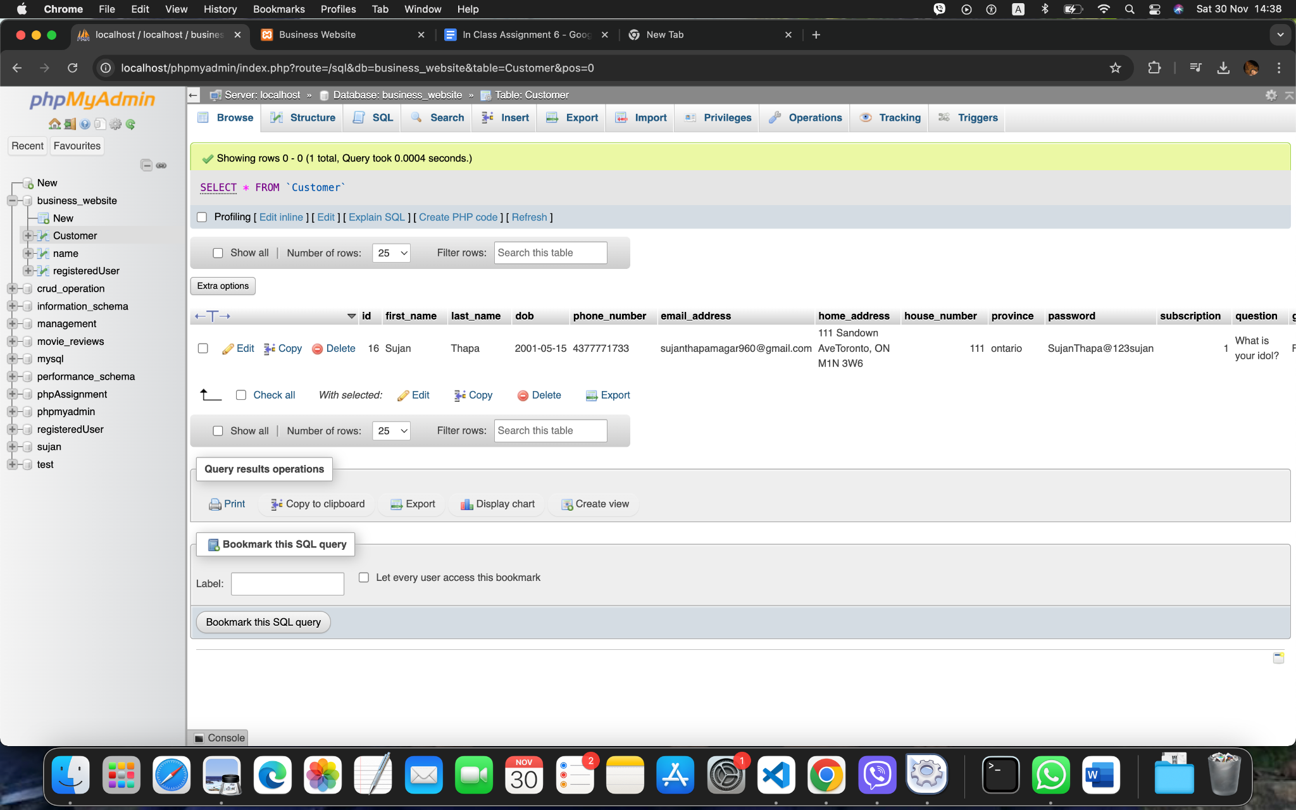

Figure 8: Successful information in the database.

DOB

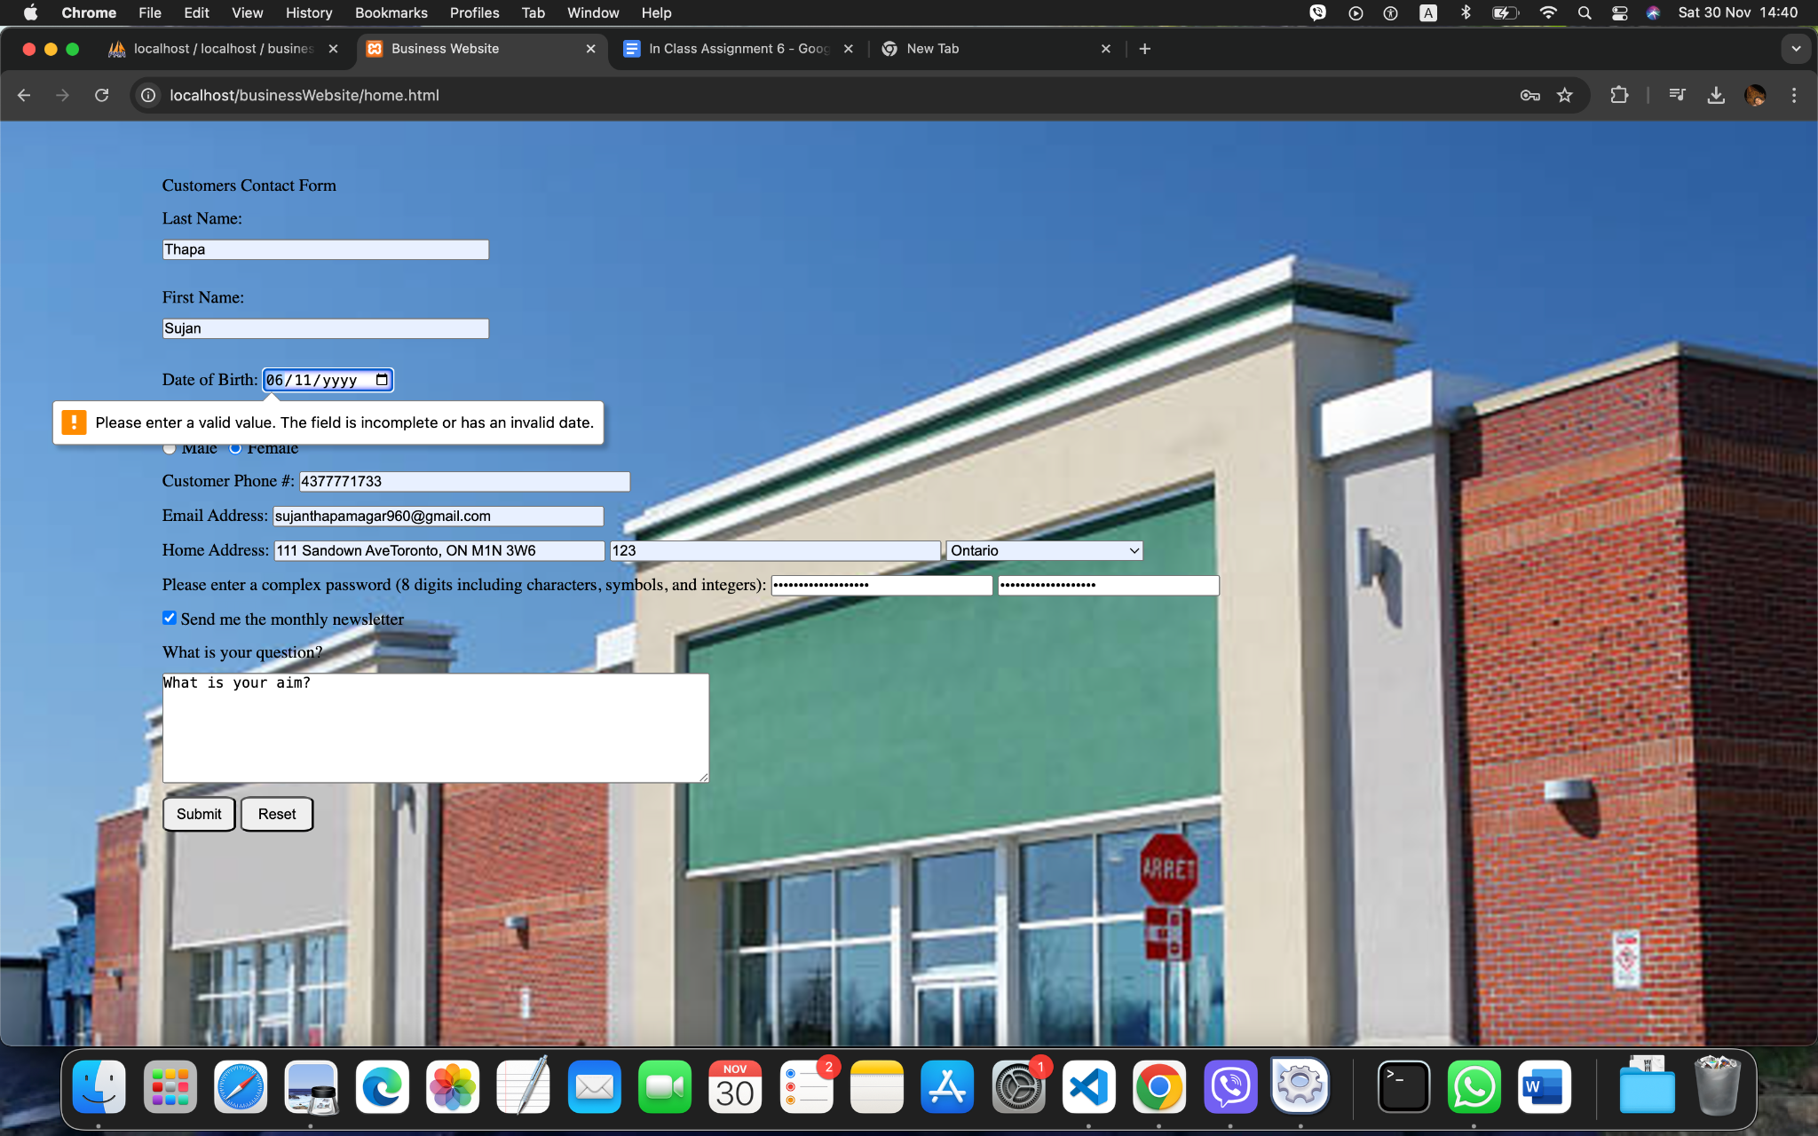

Figure 9: DOB error validation.

Gender

Email Address

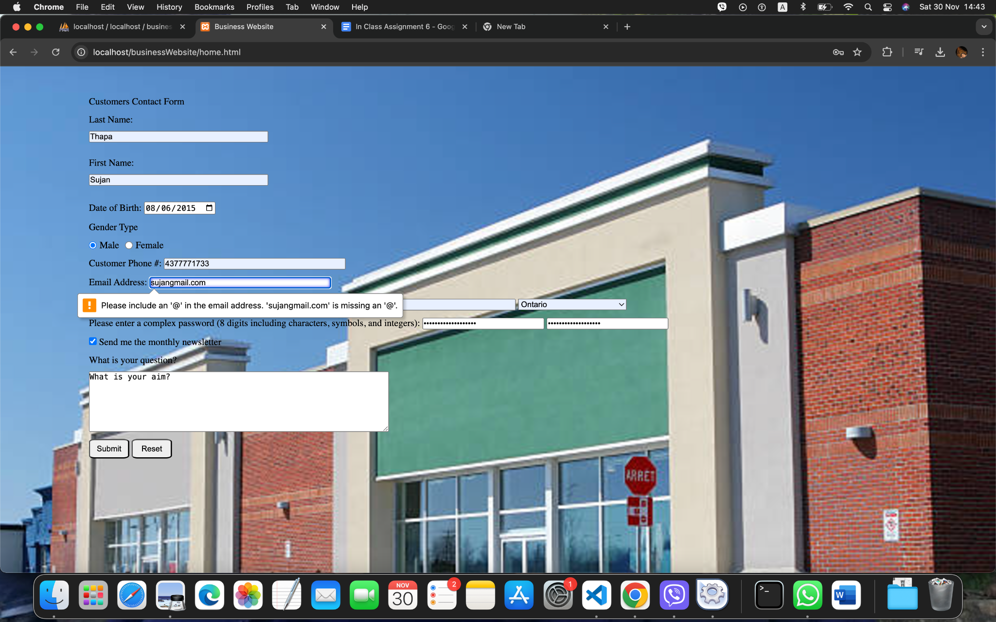

Figure 10: Email address validation.

Phone Validation

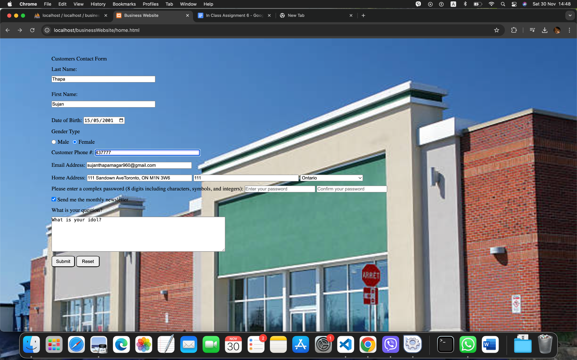

Figure 11: Phone number validation.

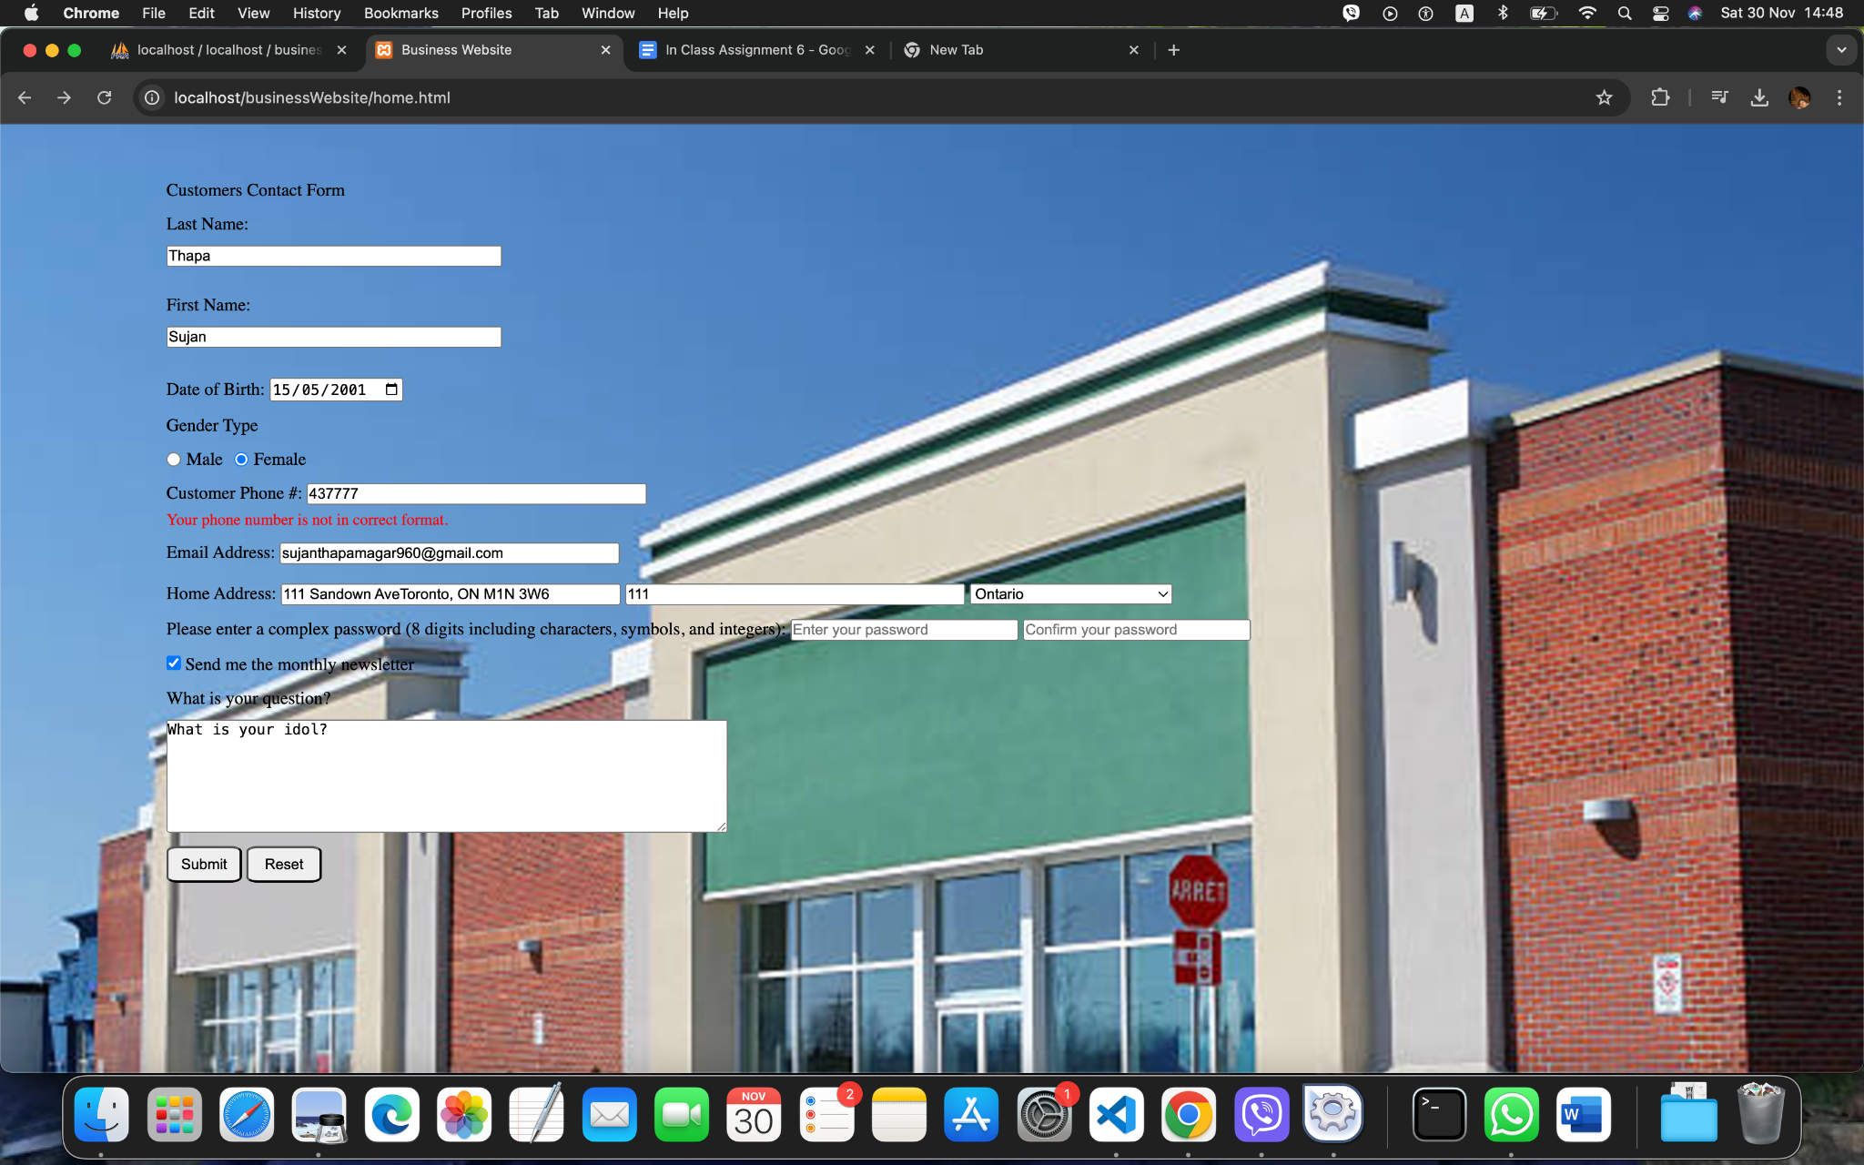

Figure 12: Showing the error message.

**Password**

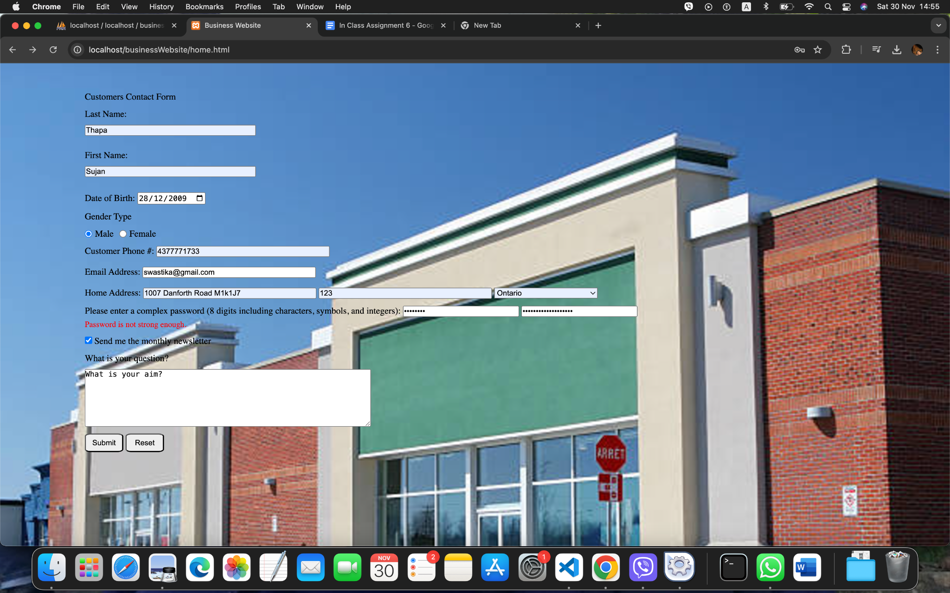

Figure 13: Password validation for weak password.

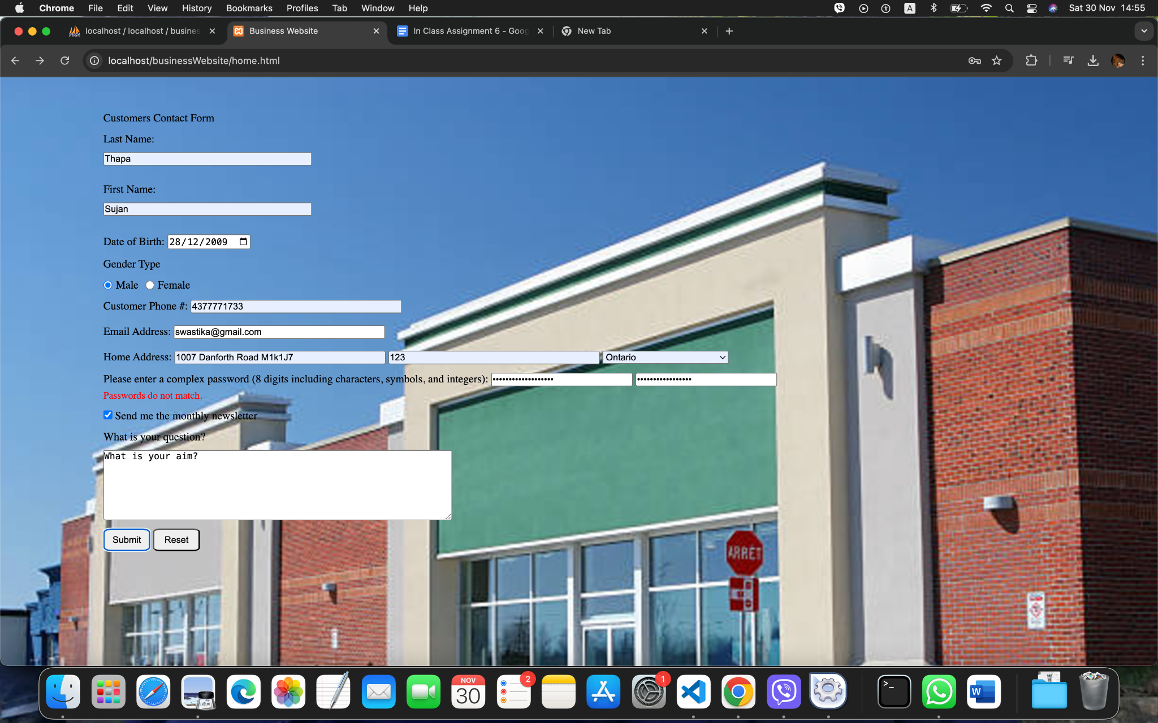

Figure 14: Password validation for confirmation.

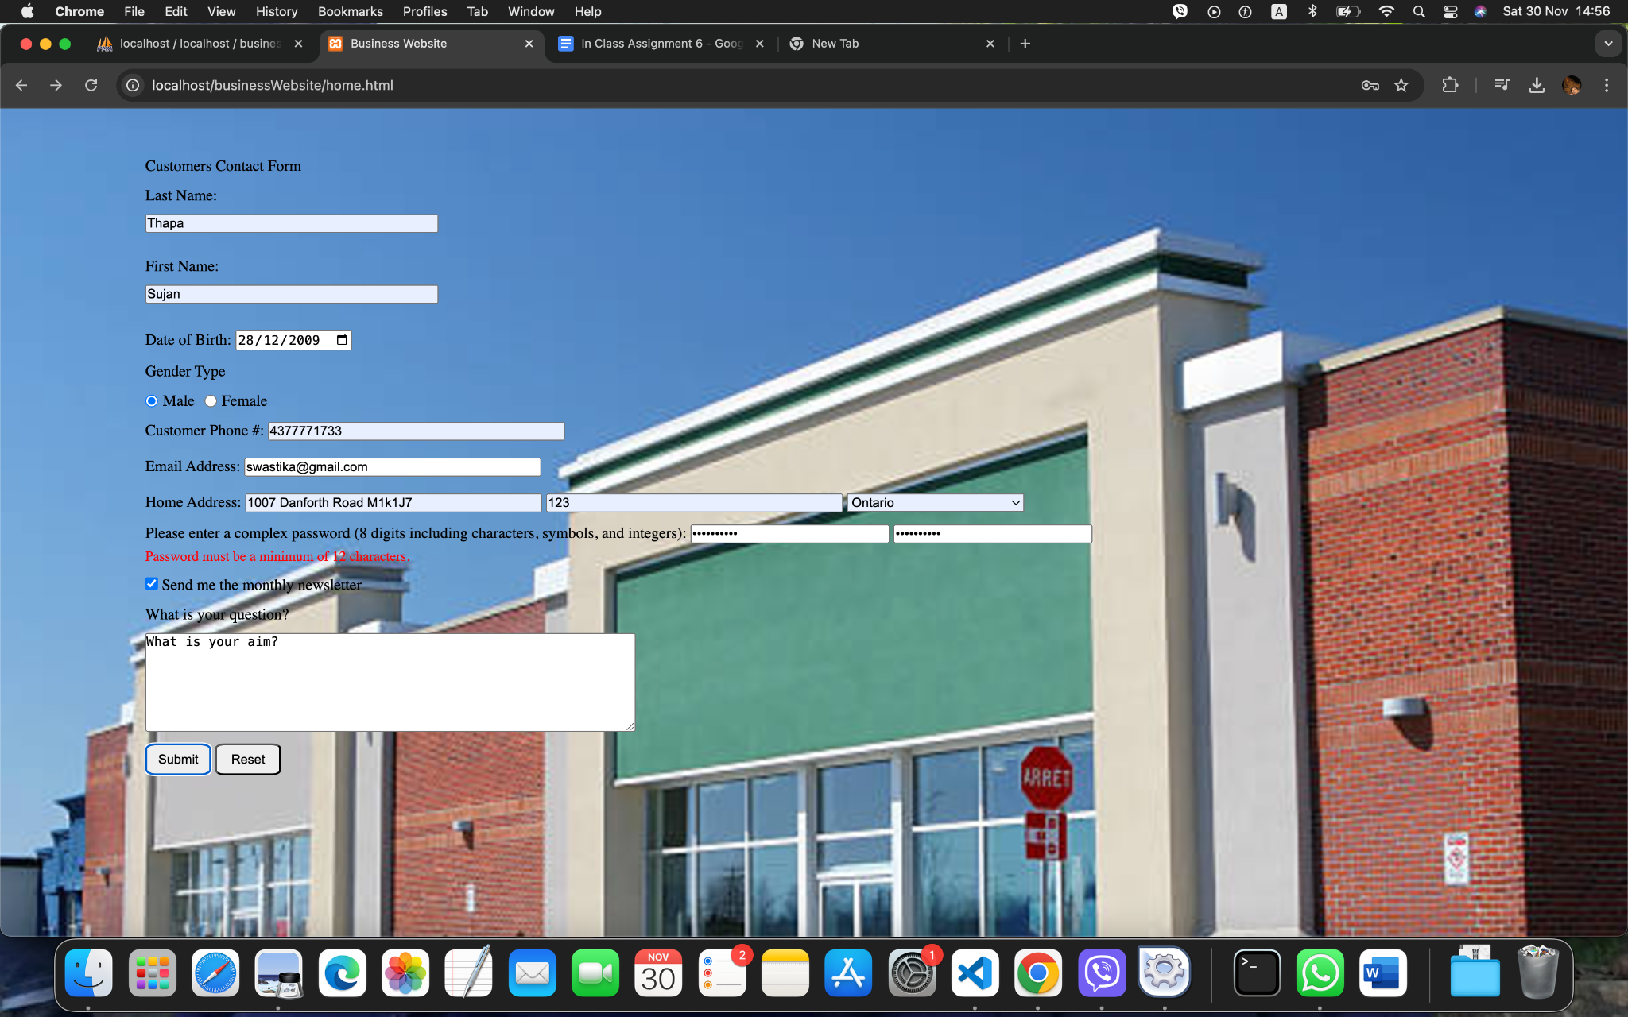

Figure 15:Password validation for minimum requirements.

**User validation**

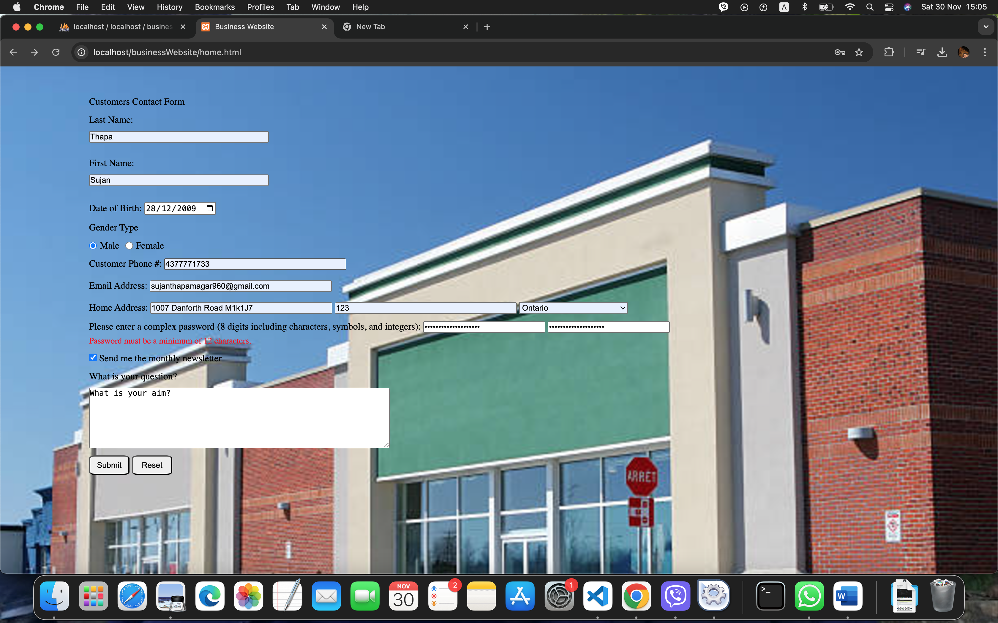

Figure 16: User validation.

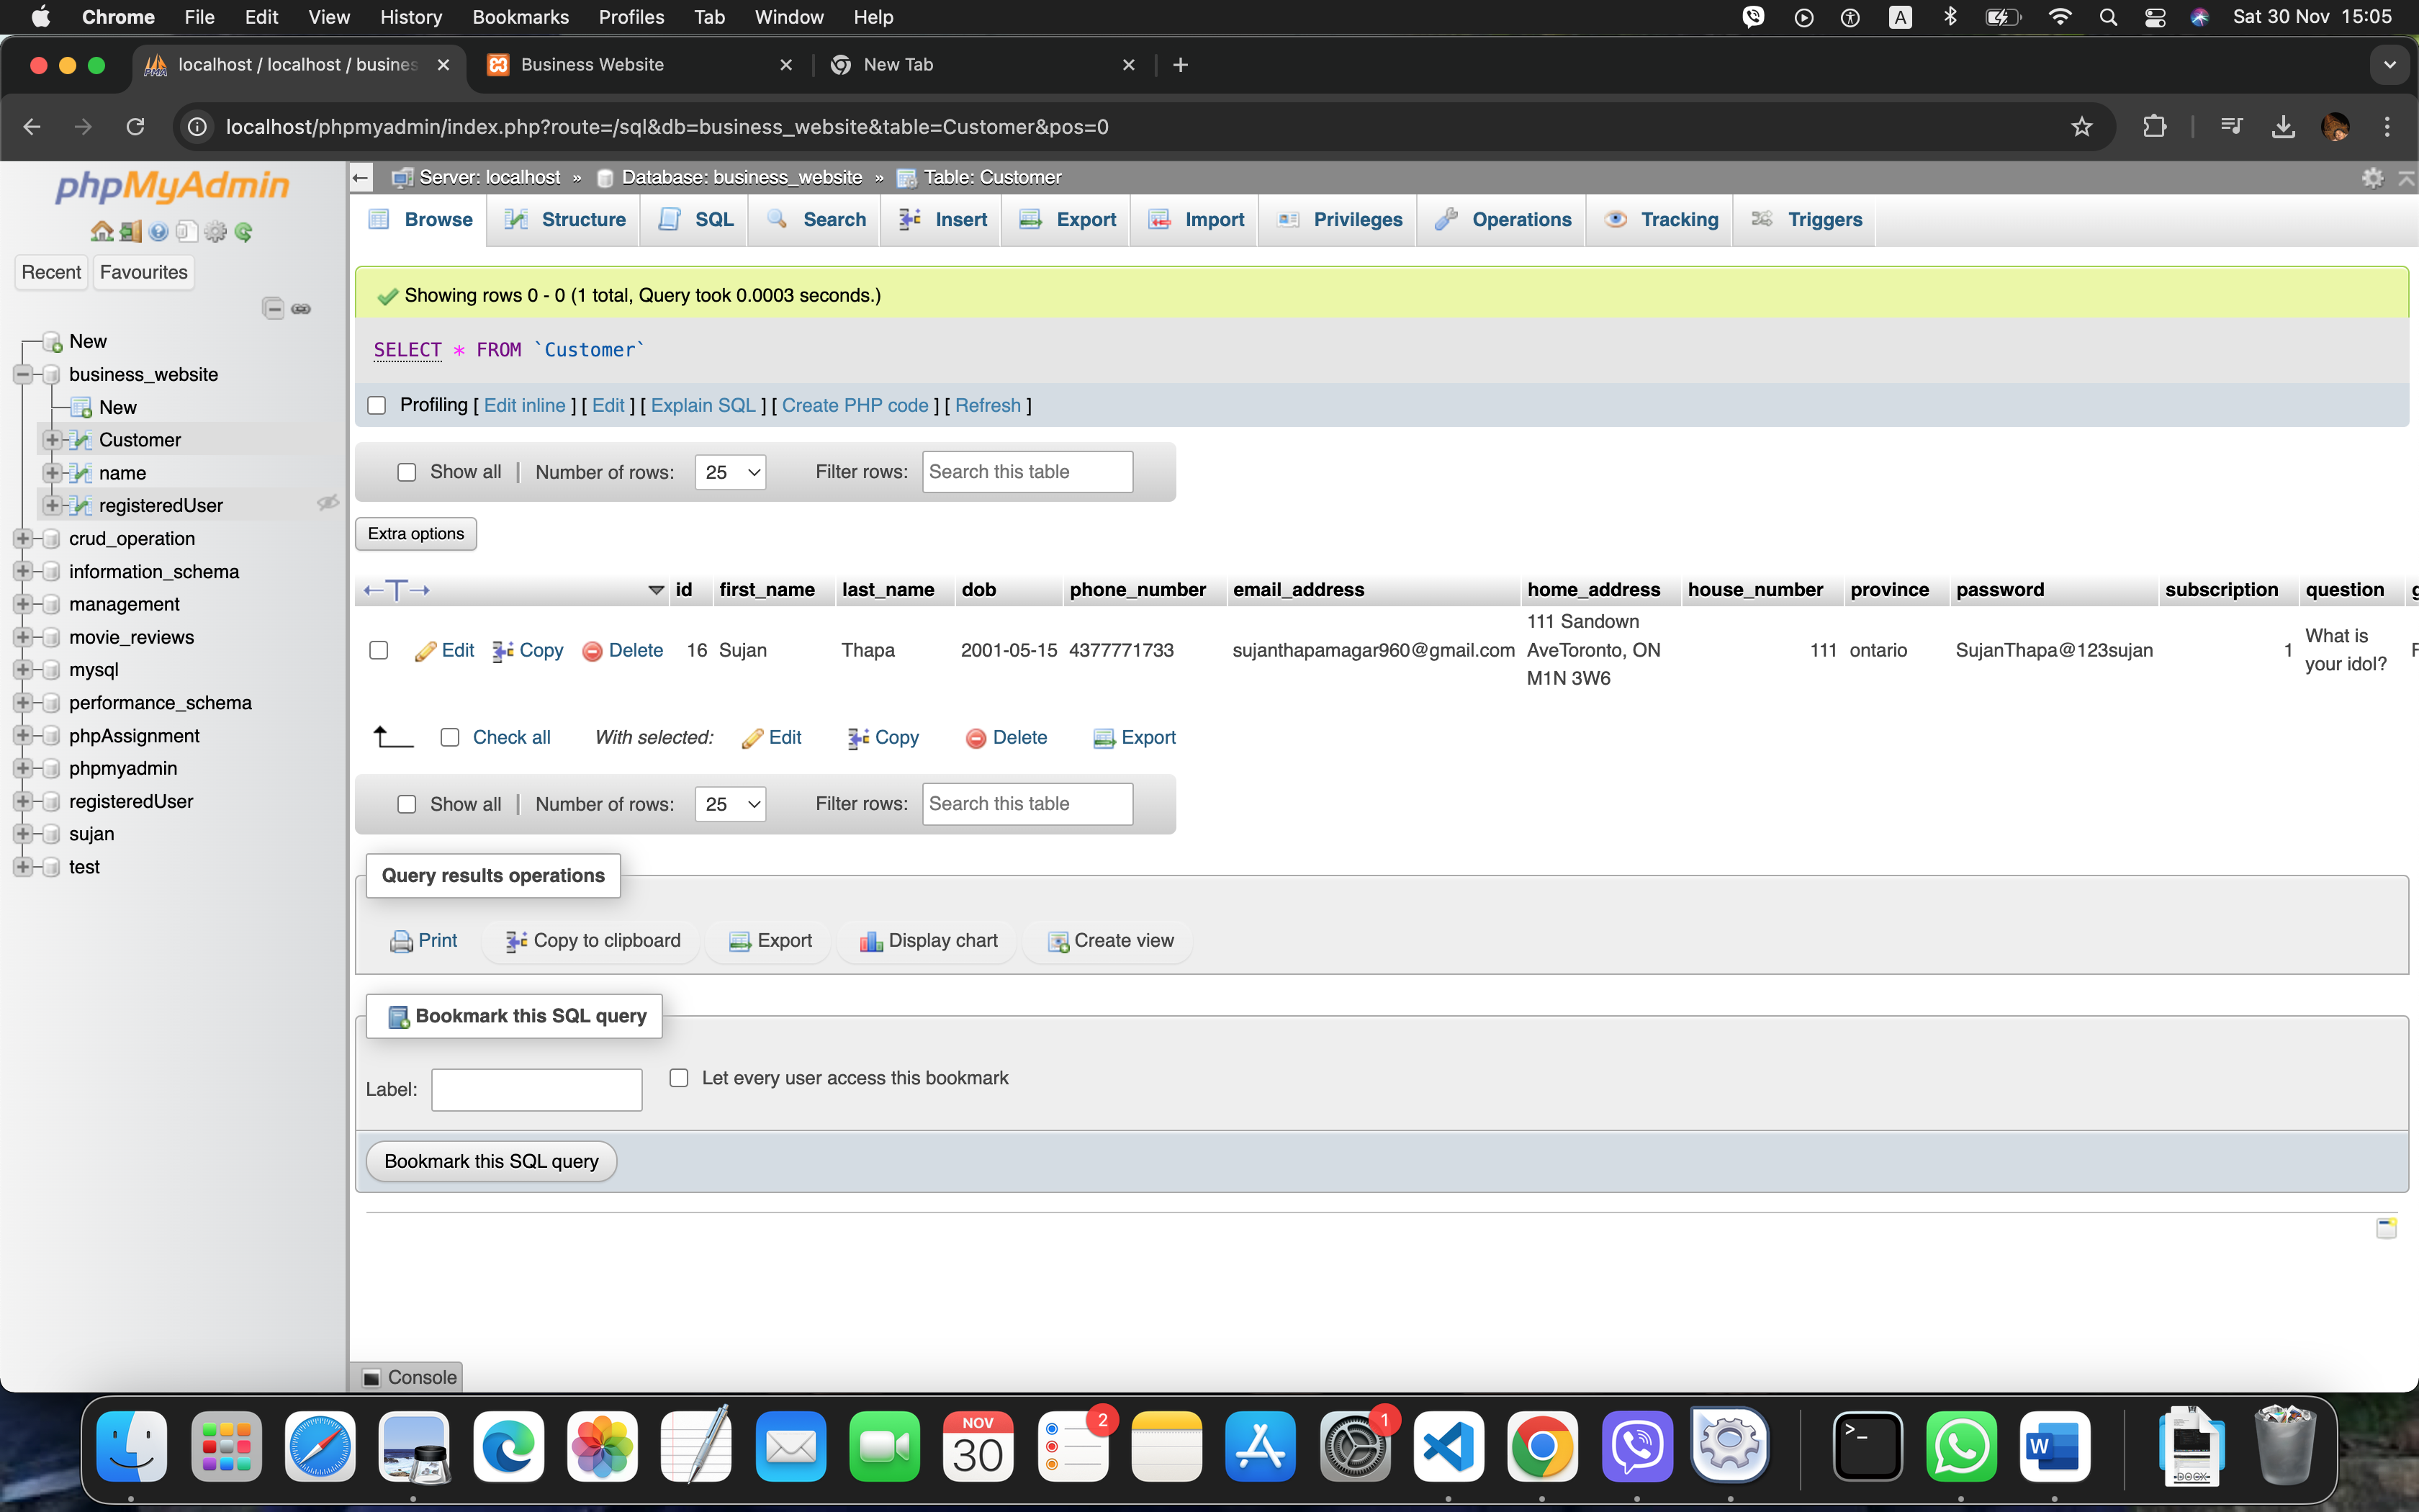

Figure 17: Existing Customer.

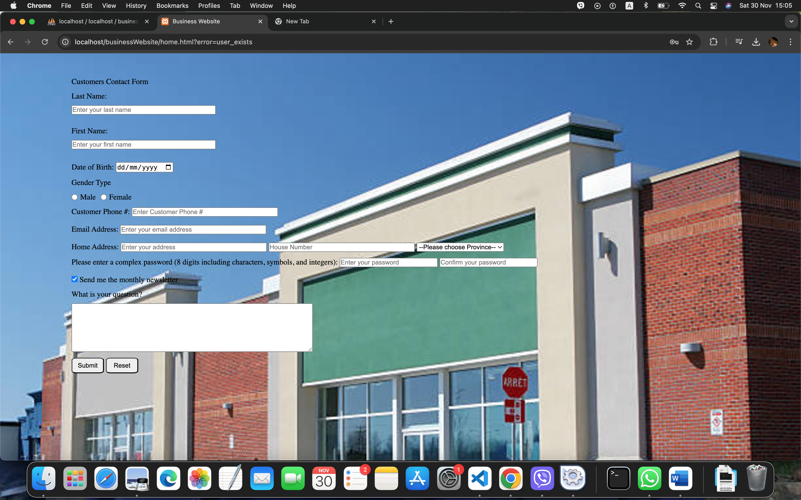

Figure 18: Throwing errror as user already exists.

**Codes for HTML, CSS, PHP and JavaScript**

HTML

<!DOCTYPE html>

<html lang="en">

<head>

<meta charset="UTF-8">

<meta name="viewport" content="width=device-width, initial-scale=1.0">

<title>Business Website</title>

<link rel="stylesheet" href="./home.css">

</head>

<body>

<div class="container">

<form id="customerForm" action="./db/migration.php" method="post" onsubmit="return check(event)">

<label for="contactForm">Customers Contact Form</label>

<!-- Name Section -->

<div class="name">

<label for="lastName">Last Name:</label>

<input type="text" name="lastName" id="lastName" placeholder="Enter your last name" required>

<span id="lastNameError" class="error"></span>

<label for="firstName">First Name:</label>

<input type="text" name="firstName" id="firstName" placeholder="Enter your first name" required>

<span id="firstNameError" class="error"></span>

</div>

<!-- dob section -->

<div class="dob">

<label for="dob">Date of Birth:</label>

<input type="date" name="dob" id="dob" placeholder="Enter your date of birth" required>

</div>

<!-- Gender Section -->

<label for="gender">Gender Type</label>

<div class="gender">

<div class="radio-item">

<input type="radio" name="gender" id="male" name="gender" value="Male" />

<label for="male">Male</label>

</div>

<div class="radio-item">

<input type="radio" name="gender" id="female" name="gender" value="Female" />

<label for="female">Female</label>

</div>

</div>

<!-- Phone Number Section -->

<div id="phoneNumber">

<label for="phone">Customer Phone #:</label>

<input type="text" name="phone" id="phone" placeholder="Enter Customer Phone #">

<span id="phoneError" class="error"></span>

</div>

<!-- Email Section -->

<div id="emailAddress">

<label for="email">Email Address:</label>

<input type="email" name="email" id="email" placeholder="Enter your email address" autocomplete="username">

<span id="emailError" class="error"></span>

</div>

<!-- Address Section -->

<div id="houseAddress">

<label for="address">Home Address:</label>

<input type="text" name="address" id="address" placeholder="Enter your address">

<input type="number" name="houseNumber" id="houseNumber" placeholder="House Number">

<select name="province" id="province-select">

<option value="">--Please choose Province--</option>

<option value="ontario">Ontario</option>

<option value="bc">British Columbia</option>

<option value="nova-scotia">Nova Scotia</option>

<option value="new-brunswick">New Brunswick</option>

<option value="alberta">Alberta</option>

<option value="quebec">Quebec</option>

</select>

</div>

<!-- Password Section -->

<div class="password">

<label for="password">Please enter a complex password (8 digits including characters, symbols, and

integers):</label>

<input type="password" name="password" id="password" placeholder="Enter your password" autocomplete="new-password">

<input type="password" id="confirmPassword" placeholder="Confirm your password"

autocomplete="new-password">

<span id="passwordError" class="error"></span>

</div>

<!-- Subscription Section -->

<div class="subscription">

<input type="checkbox" id="subscription" name="subscription" checked />

<label for="subscription">Send me the monthly newsletter</label>

</div>

<!-- Questions Section -->

<div class="questions">

<label for="question">What is your question?</label>

<textarea name="question" id="question"></textarea>

</div>

<!-- Submit and Reset Buttons -->

<div class="submit">

<button type="submit">Submit</button>

<button type="reset">Reset</button>

</div>

</form>

<!-- <span id="formMessage" class="error"></span> -->

</div>

<script src="./scripts/errorhandling.js"></script>

<script src="./scripts/validation.js"></script>

</body>

</html>

**PHP**

For database connection

<?php

// Database configuration

$servername = "127.0.0.1";

$username = "root";

$password = "";

$dbname = "business_website";

// Create connection

$conn = new mysqli($servername, $username, $password, $dbname);

// echo $conn

// Check connection

if ($conn->connect_error) {

die("Connection failed: " . $conn->connect_error);

}

// echo "Connected successfully!";

?>

For processing data into the database

<?php

require './dbconnect.php';

error_reporting(E_ALL);

ini_set('display_errors', 1);

if ($_SERVER['REQUEST_METHOD'] === 'POST') {

// Retrieve form data

$lastName = $_POST['lastName'];

$firstName = $_POST['firstName'];

$dob = $_POST['dob'];

$gender = $_POST['gender'];

$phone = $_POST['phone'];

$email = $_POST['email'];

$address = $_POST['address'];

$houseNumber = $_POST['houseNumber'];

$province = $_POST['province'];

$password = $_POST['password'];

$subscription = isset($_POST['subscription']) ? 1 : 0; // Default to 0 if not set

$question = $_POST['question'];

$userExists = false;

// Use a prepared statement to prevent SQL injection

$sql = "SELECT email_address FROM Customer WHERE email_address = ?";

$stmt = $conn->prepare($sql);

// Check if the statement is prepared correctly

if ($stmt === false) {

die('Error preparing statement: ' . $conn->error);

}

// Bind the email parameter to the prepared statement

$stmt->bind_param("s", $email); // "s" means string type

// Execute the query

$stmt->execute();

// Get the result

$result = $stmt->get_result();

// Check if any rows were returned (meaning the email exists)

if ($result->num_rows > 0) {

$userExists = true;

// Redirect to home.php with a message, but without outputting first

header("Location: ../home.html?error=user_exists");

// header("Location: ../home.php");

exit(); // Always call exit after header redirection

}

// Prepare SQL query with placeholders

$sql = "INSERT INTO Customer (`first_name`, `last_name`, `dob`, `phone_number`, `email_address`, `home_address`, `house_number`, `province`, `password`, `subscription`, `question`, `gender`)

VALUES (?, ?, ?, ?, ?, ?, ?, ?, ?, ?, ?, ?)";

$stmt = mysqli_prepare($conn, $sql);

// Check if the preparation of the statement was successful

if ($stmt === false) {

die('Error preparing statement: ' . mysqli_error($conn));

}

// Bind parameters to the placeholders

mysqli_stmt_bind_param($stmt, "ssssssssssss", $firstName, $lastName, $dob, $phone, $email, $address, $houseNumber, $province, $password, $subscription, $question, $gender);

// Execute the query

if (mysqli_stmt_execute($stmt)) {

// echo "Data inserted successfully!";

header("Location: ../home.html");

} else {

echo "Error: " . mysqli_stmt_error($stmt);

}

// Close the statement

mysqli_stmt_close($stmt);

}

**CSS**

*{

margin: 0;

padding: 0;

}

body{

background-image: url("./assets/store.jpg");

background-repeat: no-repeat;

background-size: cover;

}

.container {

width: 100vw;

height: 100vh;

}

input:focus{

box-shadow: 0 0 5px blue inset;

}

/* .container > img{

width: 100%;

height: auto;

background-repeat: no-repeat;

background-size: cover;

} */

#customerForm{

margin: 0 100px;

width: 60%;

display: flex;

flex-direction: column;

padding: 50px;

gap: 12px;

}

/* #customerForm, */

.name{

display: flex;

flex-direction: column;

width: 30%;

gap: 10px;

}

.error{

color: red;

font-size: 0.9em;

display: block; /* Ensures the error spans are visible */

margin-top: 5px;

}

.gender {

display: flex;

gap: 10px;

}

.radio-item {

display: flex;

align-items: center;

gap: 5px;

}

#phoneNumber > input{

width: 30%;

}

#emailAddress > input{

width: 30%;

}

#houseAddress > input{

width: 30%;

}

.password > input{

width: 20%;

}

.questions{

display: flex;

flex-direction: column;

gap: 10px;

}

.questions > textarea{

width: 50%;

height: 100px;

}

.submit > button{

width: 68px;

height: 33px;

border-radius: 15%;

}

**JavaScript**

function nameGender() {

const lastName = document.getElementById("lastName").value.trim();

const firstName = document.getElementById("firstName").value.trim();

const firstNameError = document.getElementById("firstNameError");

const lastNameError = document.getElementById("lastNameError");

let valid = true;

const minCharacter = 2;

// Reset previous error messages

firstNameError.textContent = "";

lastNameError.textContent = "";

// Check if last name is of minimum 2 characters

if (lastName.length < minCharacter) {

lastNameError.textContent = "Last Name must be at least 2 characters.";

valid = false;

}

// Check if first name is of minimum 2 characters

if (firstName.length < minCharacter) {

firstNameError.textContent = "First Name must be at least 2 characters.";

valid = false;

}

const male = document.getElementById("male");

const female = document.getElementById("female");

if (!male.checked && !female.checked) {

console.log("You have to select one gender.");

valid = false;

}

return valid;

}

function emailValidation() {

const emailRegex = /^[^\s@]+@[^\s@]+\.[^\s@]+$/;

const email = document.getElementById("email").value.trim();

const emailError = document.getElementById("emailError");

if (!emailRegex.test(email)) {

emailError.textContent = "Your email address is not in correct format.";

}

return emailRegex.test(email);

}

function phoneValidation() {

const phoneNumber = document.getElementById("phone").value.trim();

const phoneRegex = /^\(?(\d{3})\)?[-.\s]?\d{3}[-.\s]?\d{4}$/;

const phoneError = document.getElementById("phoneError");

if (!phoneRegex.test(phoneNumber)) {

phoneError.textContent = "Your phone number is not in correct format.";

}

return phoneRegex.test(phoneNumber);

}

function check(event) {

event.preventDefault(); // Prevent default form submission

let validity = true;

// Validate name and gender

if (!nameGender()) validity = false;

// Validate email

if (!emailValidation()) {

console.log("Invalid email.");

validity = false;

}

// Validate phone number

if (!phoneValidation()) {

console.log("Invalid phone number.");

validity = false;

}

// Validate passwords

const password = document.getElementById("password").value.trim();

const confirmPassword = document.getElementById("confirmPassword").value.trim();

const minChar = 12;

const strongPasswordRegex = /^(?=.*[a-z])(?=.*[A-Z])(?=.*\d)(?=.*[@$!%*?&])[A-Za-z\d@$!%*?&]{8,}$/;

const passwordError = document.getElementById("passwordError")

if (password.length < minChar) {

// console.log("Password must be a minimum of 12 characters.");

passwordError.textContent = "Password must be a minimum of 12 characters.";

validity = false;

}

if (password !== confirmPassword) {

// console.log("Passwords do not match.");

passwordError.textContent = "Passwords do not match.";

validity = false;

}

if (!strongPasswordRegex.test(password)) {

console.log("Password is not strong enough.");

passwordError.textContent = "Password is not strong enough.";

validity = false;

}

// Submit form only if all validations pass

if (validity) {

console.log("Form submitted successfully!");

event.target.submit(); // Manually trigger form submission

}

}